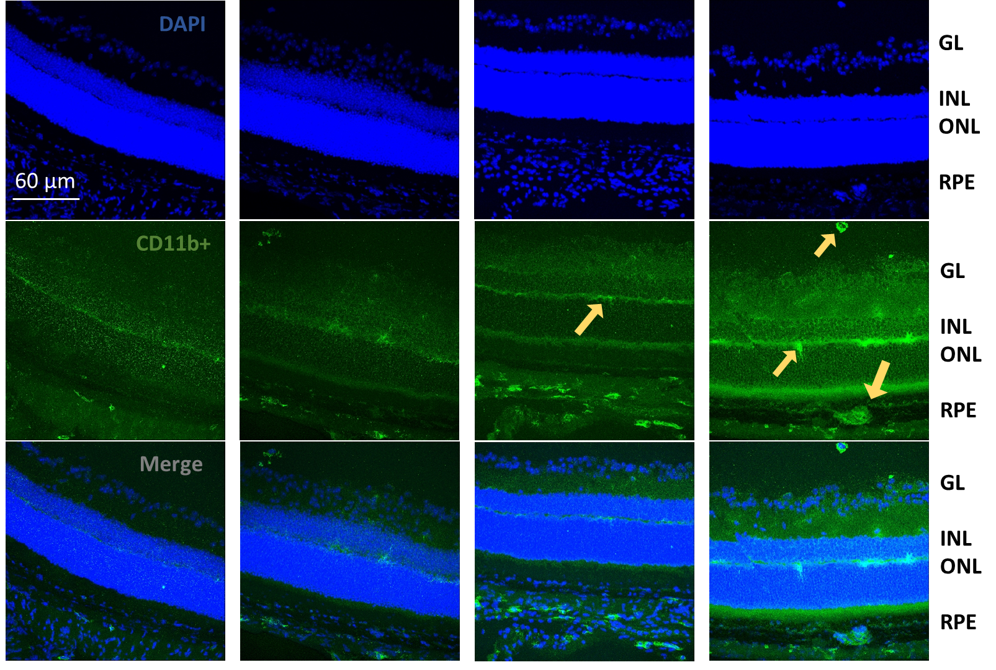**Figures and figure legends**

**Figure 1:** Images of the stained retinal sections have been taken by confocal microscope. These are representative images showing difference in number of CD11b+ stained cells in the retina. The top row of pictures is stained with DAPI and all nuclei are stained blue. Green staining shows the CD11b+ expressed cells. The yellow arrows pointing at the brighter areas represent the presence of activated myeloid cells within different layers of retina.

**KO light-induced**

**WT light-induced**

**WT Control**

**KO Control**

**b**

**Figure 2**: (**a)** Bar chart showing the quantification for Figure 1. Confocal images of 10 retinal sections across the entire retina were taken. Numbers of CD11b+ expressed cells were counted in each section and were compartmentalised within the 4 layers of the retina. This data was then used to generate the bar chart using GraphPad Prism. The figure represents an overall increased the number of CD11b+ cells in KO light induced eye compared to WT. However, both controls had similar number of CD11b+ cells.

**b)** Tukey’s multiple comparisons test shows the result of statistical analysis of Figure 2. This statistical data is generated using GraphPad 8 Prism using two way ANOVA. *P<0.05, **P<0.01, ****P<0.0001.

**a**